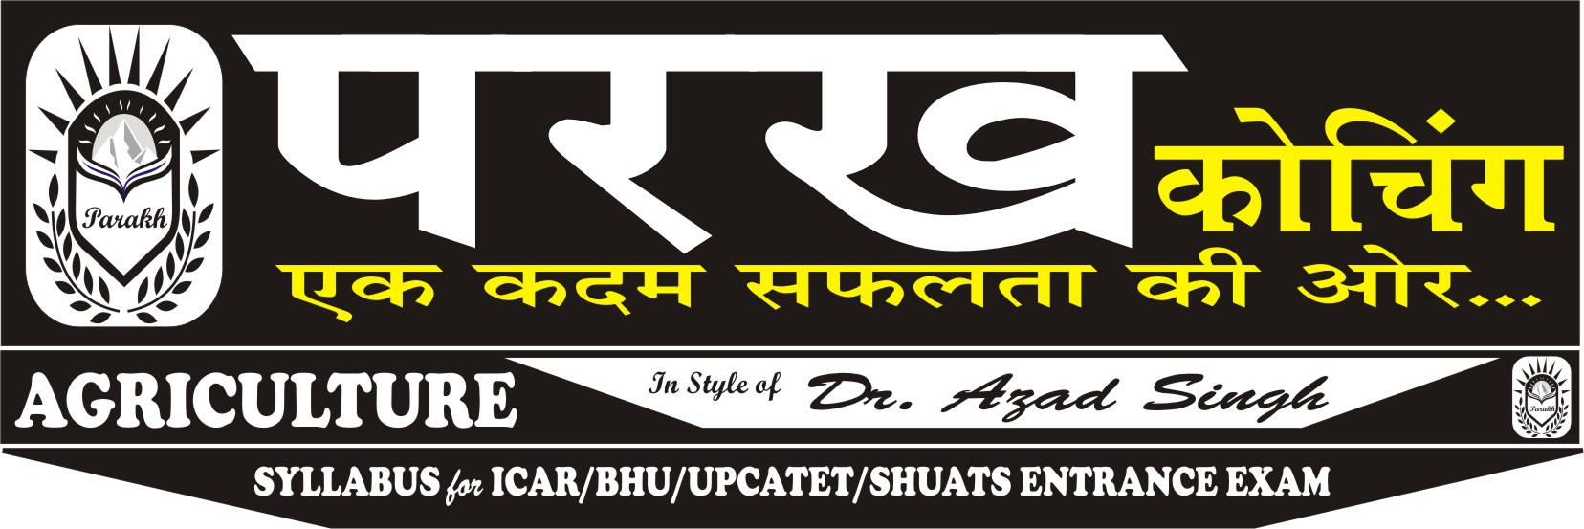
AGRICULTURE TEST-06 ANSWER KEY - 7
- C
- B
- D
- A
- B
- B
- A
- A
- C
- B
- A
- C
- C
- D
- B
- D
- C
- B
- B
- D
- B
- A
- B
- C
- A
- C
- D
- D
- C
- C
- A
- B
- C
- C
- A
- B
- C
- A
- D
- C
- B
- C
- A
- D
- A
- D
- A
- B
- D
- C
- A
- C
- A
- B
- D
- A
- C
- B
- A
- B
- B
- D
- C
- C
- C
- D
- C
- C
- C
- B
- D
- A
- C
- B
- C
- C
- D
- A
- B
- C
- B
- C
- D
- B
- C
- A
- D
- B
- C
- B
- D
- B
- C
- C
- A
- D
- C
- B
- C
- C
- A
- C
- A
- B
- A
- D
- C
- D
- A
- B
- B
- C
- D
- B
- A
- B
- D
- A
- A

